Domayne’s Form & Steel Dining Set

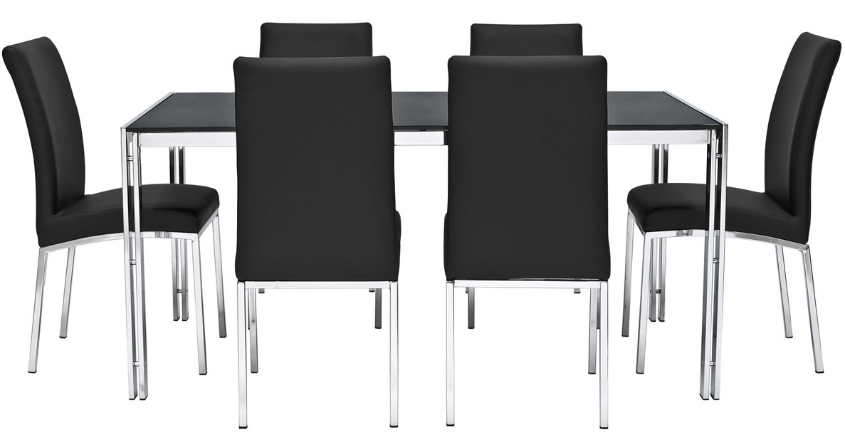

|  |
| --- |
| **DESCRIPTION** |
| Domayne introduces stylish formed dining set with a rich metallic finish the set of tables and chairs is perfect to create the perfect look for family gathering. The rich stainless steel with form on top gives you feeling of happiness. Perfect for you and your family. |

|  |  |  |
| --- | --- | --- |
| **Price** | **1350$** | |
| **Dimensions** | **Table H** x **W** x **L** | **45in x 40in x 55in** |
| **Chairs H** x **W** x **L** | **30in x 16in x 20.5in** |
| **Features** | **Six Chairs and One Table with form on top prove to give you complete comfort and relaxes your entire body reduces back problems.** | |
| **Finished** | **Black Form** | |
| **Available in** | **Silver Black Only** | |